Leadership Mini Camp

- What is A Leader?

- Everyday Leadership Video

- Olympic Values

- As I Am Now

- 5 Minute Personality Test

- Dr. Tim Video

- Leadership Opportunities

- Servant Leadership Goals

- Developing a Personal Motto

What is a Leader?

Think about the people in your life that you consider a great leader. Type in the chat who that person is.

Now think about that person and answer the following questions.
- What characteristics make a great leader?
- What characteristics make a bad leader?

Great Leaders

Bad Leaders

Olympic Values

Good leaders should always strive to exemplify each Olympic Value. Take some time to think about the questions below and share some examples.

Excellence
- What is one way you can strive for excellence (in band, school, at home)?

Respect
- What is one time you saw someone demonstrate respect for others (parents, teachers, peers, strangers)?

Friendship
- Talk about a time that you saw someone show friendship to a band family member.

As I Am Now:
My Relationship with my family:

My Relationship with my friends:

Who I am when no one else is around:

What I value now:

My Goals in education:

My Goals in family life:

What I must do to reach these goals:

How I spend my time alone:

Does this align with my goals:

Skills and interests I must focus to reach these goals:

My goals to reach at high school graduation:

My goals to reach at college graduation:
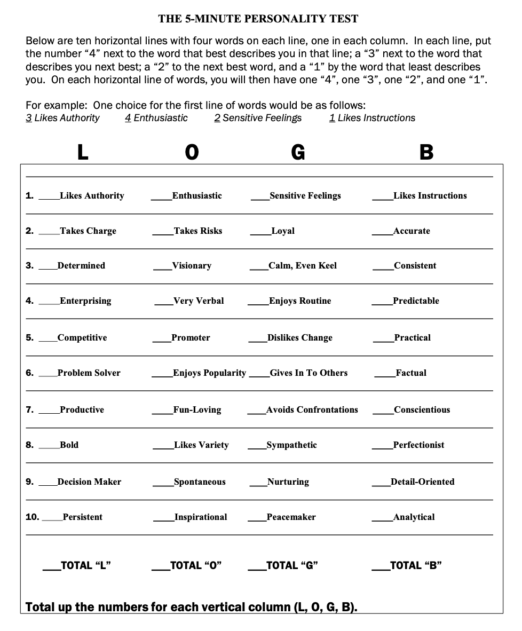
Leadership Opportunities
“Leading well is not about enriching yourself--it’s about empowering others.” --John C. Maxwell

- Band Council
  - ANYONE can come to meetings
  - Help plan social events
  - Learn about officer positions
  - Make new friends
  - Find a place to belong

- Band Council Officers
  - Must apply/be elected
  - President
  - Vice President
  - Secretary
  - 8th Grade Representative (2)
  - 7th Grade Representative (2)

Servant Leadership Goals

How can we use the Olympic Values to create a service project for our band, school, or community this year?

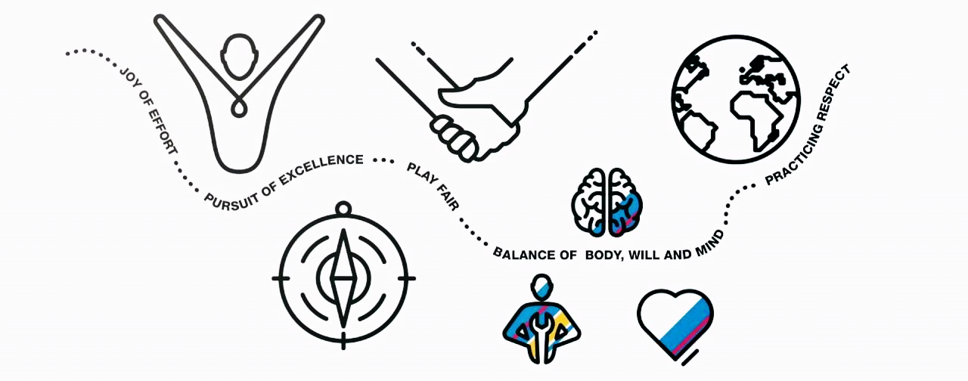

- What is ONE thing you love about band?

- What is ONE thing we most need to improve on as a band?

- If there was ONE thing the band could accomplish this year, what would you want it to be?

- What do you think would be a good service project for our band to give back to our school and community?

- What words most describe what you want our band program to be like?

Personal Motto

- Finish these two sentences:
  - Last year, I wish:

  - This year, I want to:

- Are there any words or ideas that jumped out to you today?

- When things get tough, what ideas from today would help you get through it?

- If you could achieve ONE thing this year, what would you want it to be?

Using your brainstorm from the questions above, write ONE sentence to motivate you throughout the year.

My personal motto is:

